**Stored Procedure**

***Exercise 1: Create a Stored Procedure***

**1)Code**

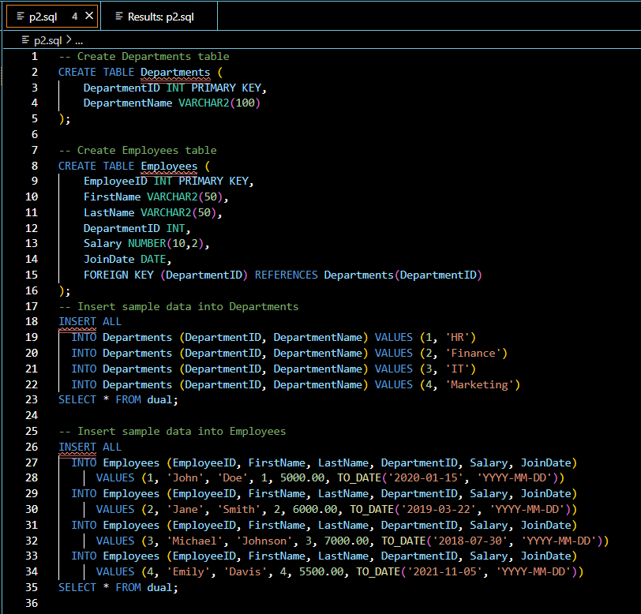

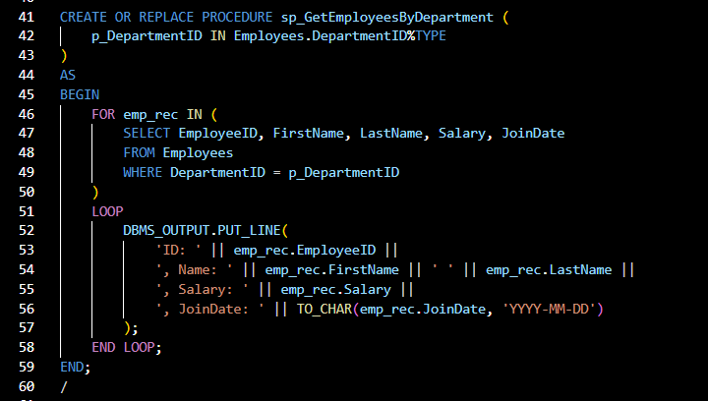

**2)Output**

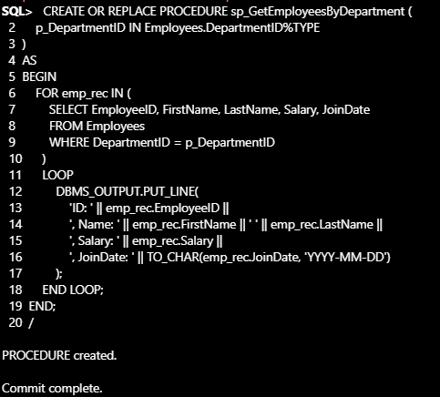

***Exercise 5: Return Data from a Stored Procedure***

**1)Code**

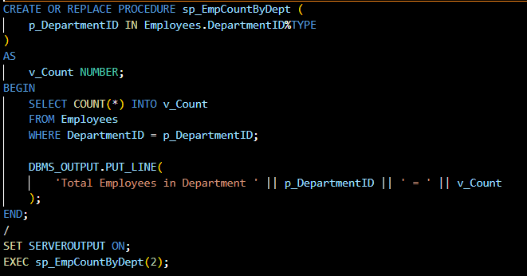

**2)Output**

